Unit 4

**UNIT - 4 (16 hours)**

**Silicon semiconductor technology**: Wafer processing, oxidation, epitaxy, deposition, etching, Photo-Lithography, Ion-implantation and diffusion. Silicon gate process. Chemical Vapor Deposition.

Explain basic planar process involved in fabrication of IC?

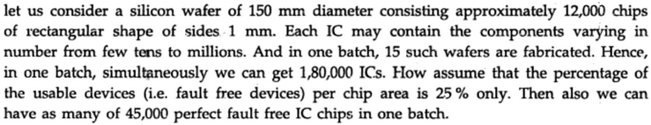

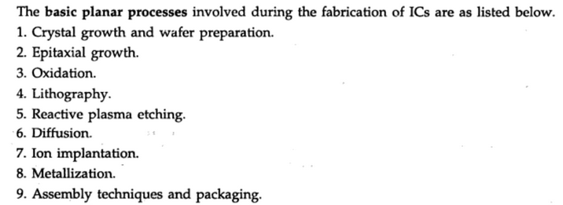

Explain silicon wafer through the crystal growth using czochralski method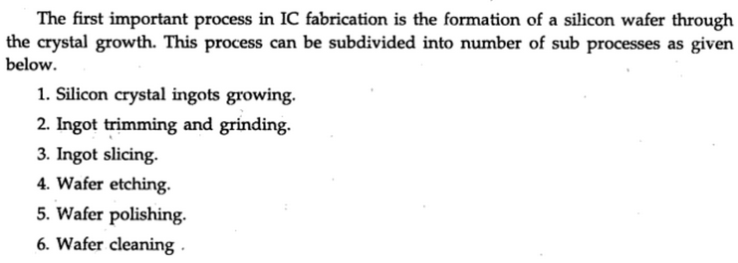



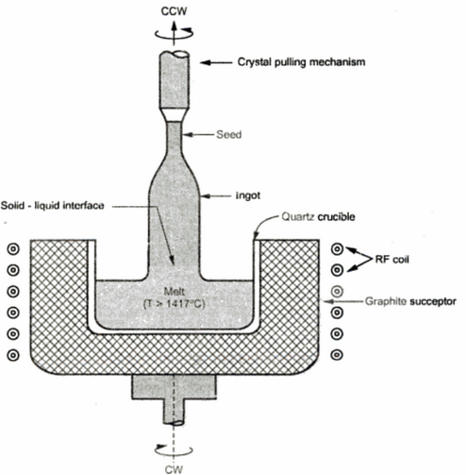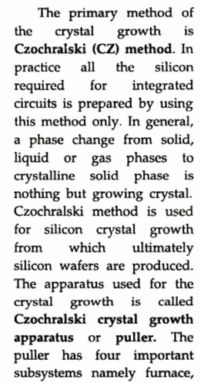



.

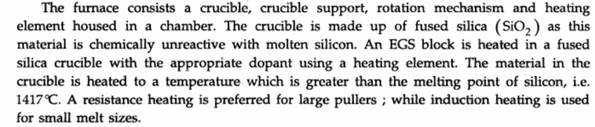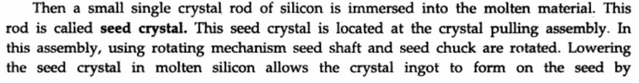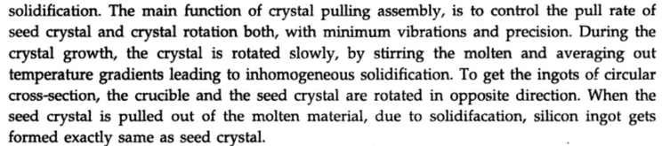

Explain NMOS fabrication

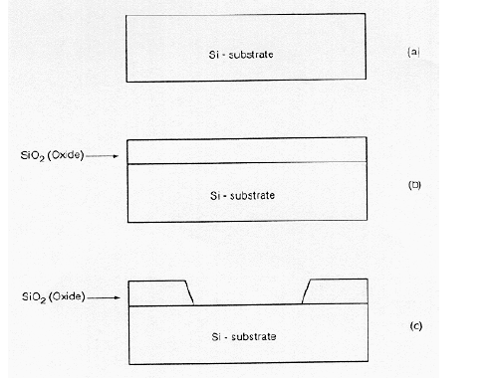

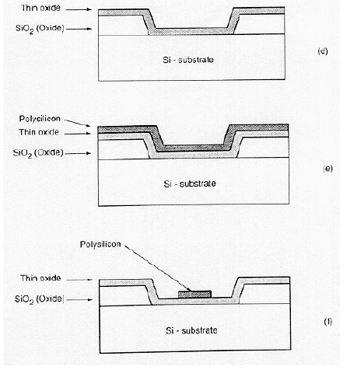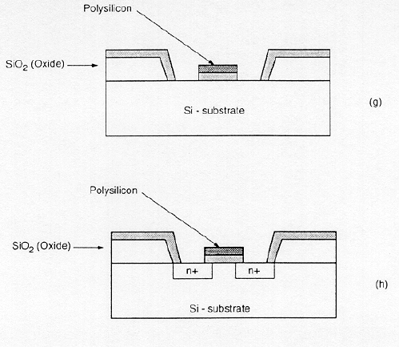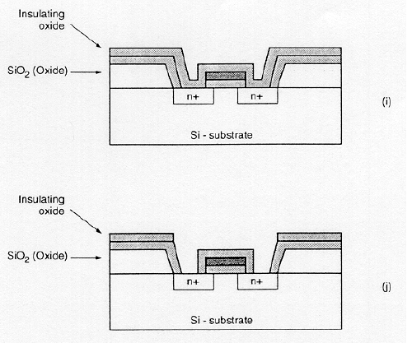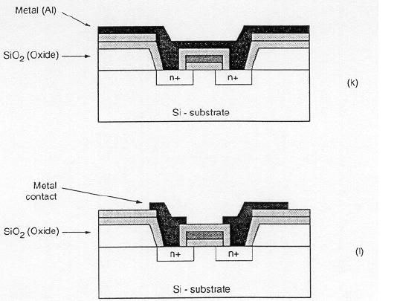

Explain Epitaxy process and what are advantages of epitaxial growth



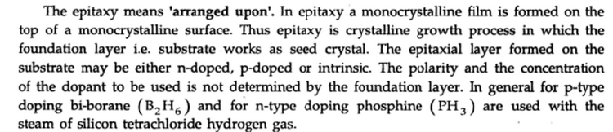

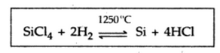

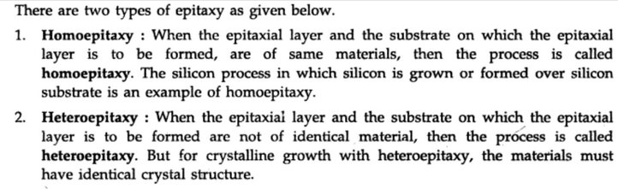

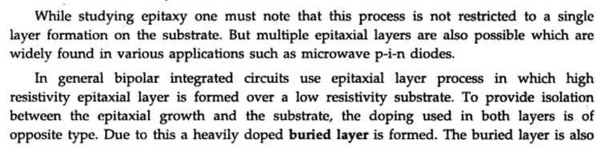

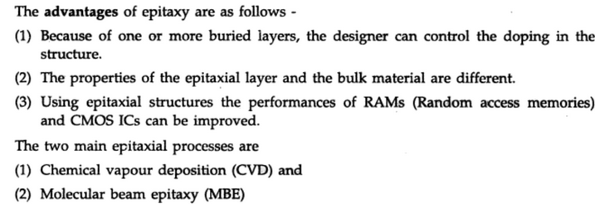

*Describe vapour and molecular beam epitaxy*

**

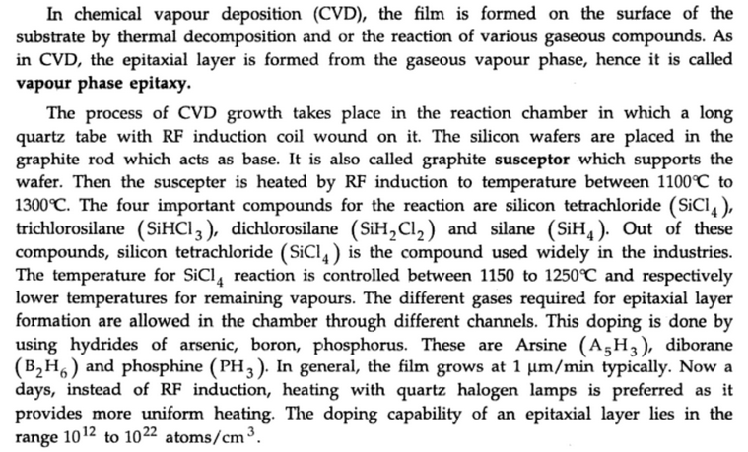

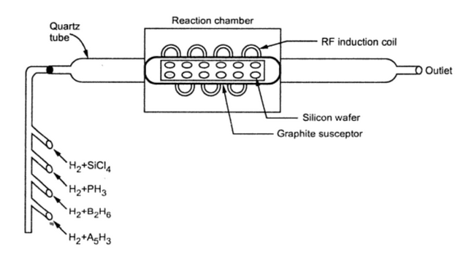

**

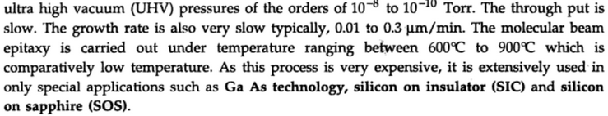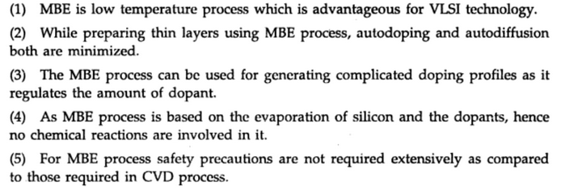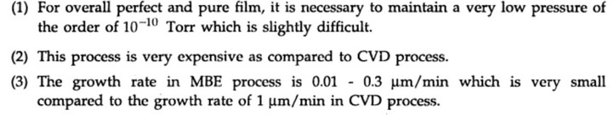

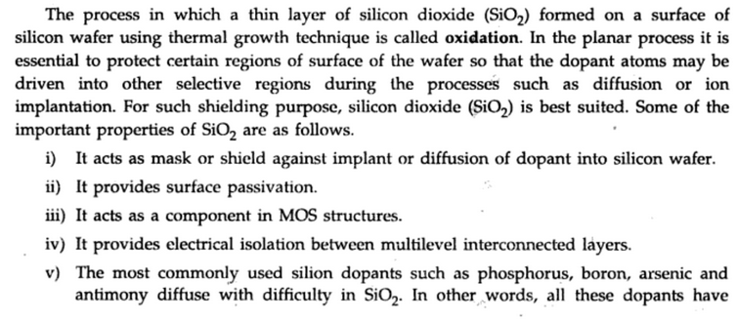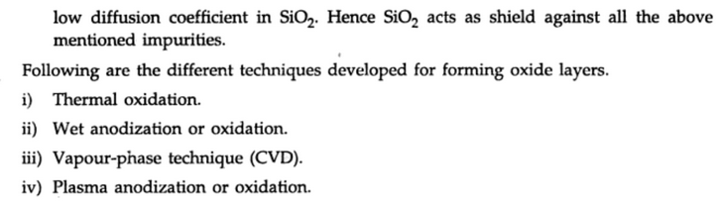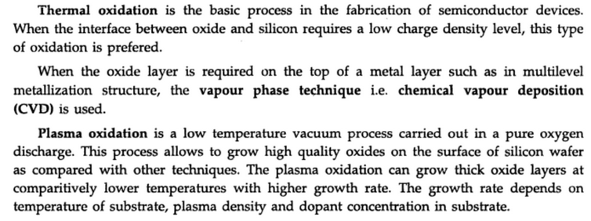

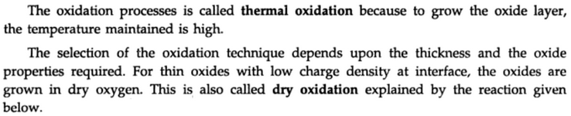

**

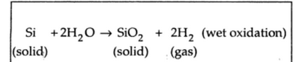

**

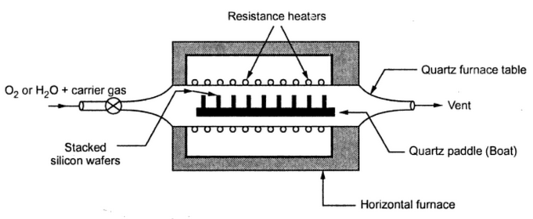

**

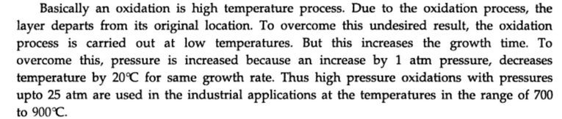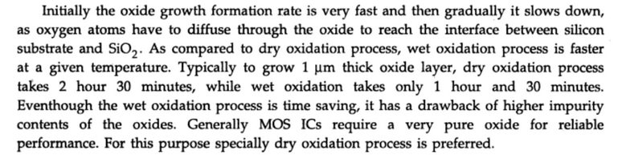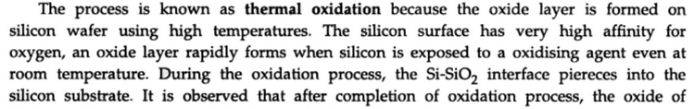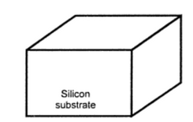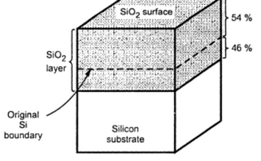 

**

*Explain Lithography process*

**

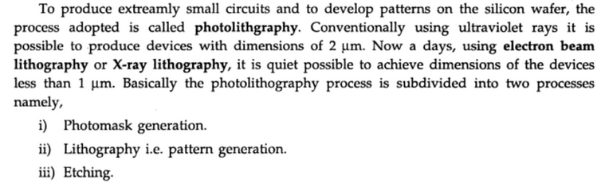

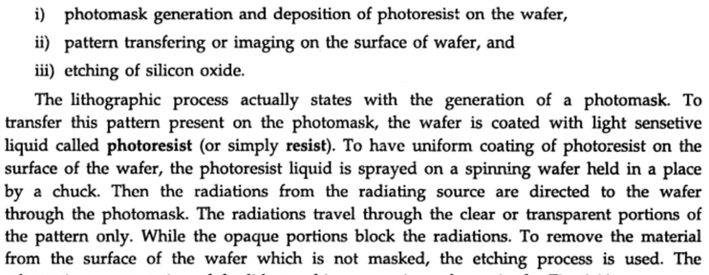

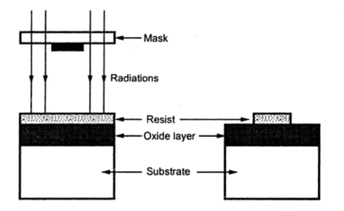

**

**

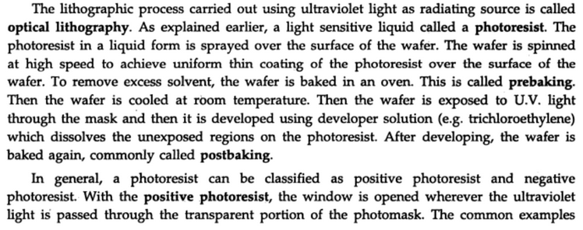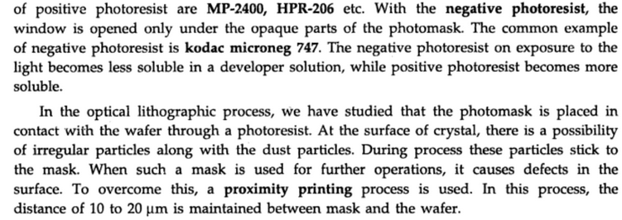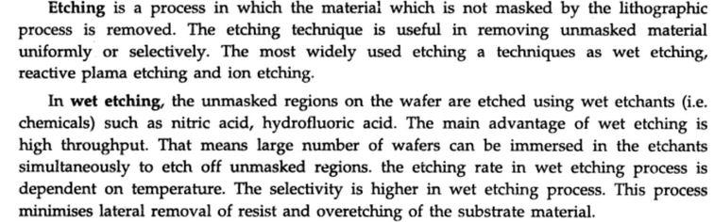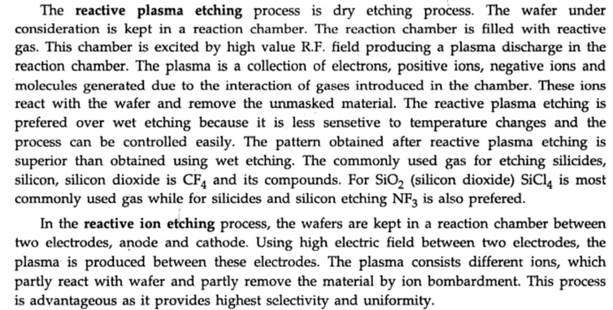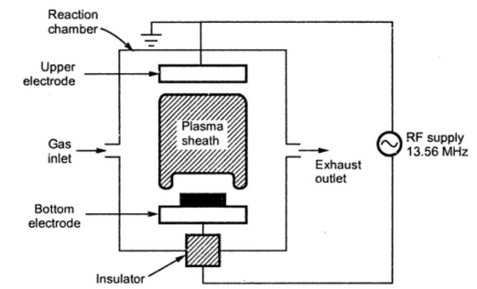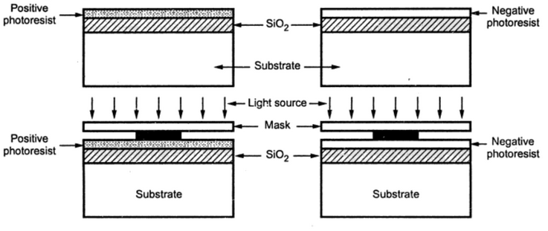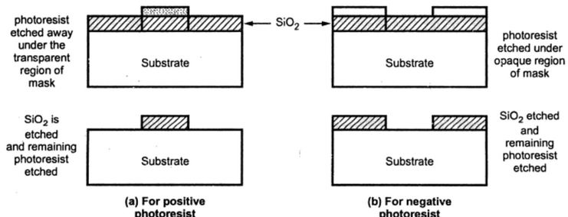

**

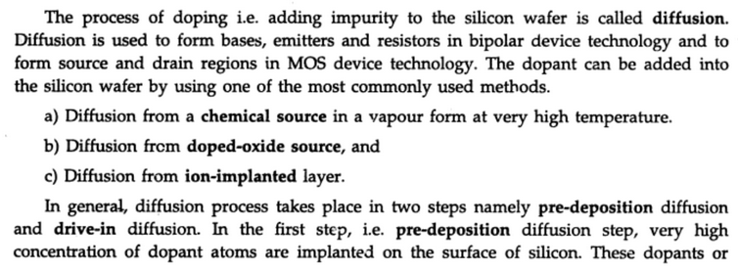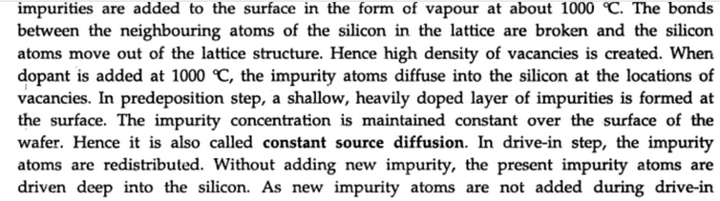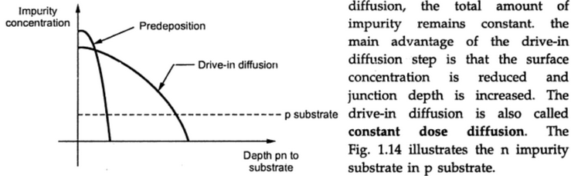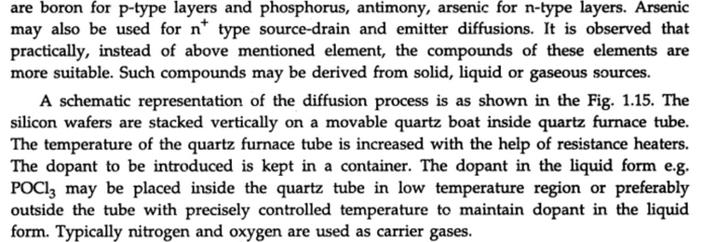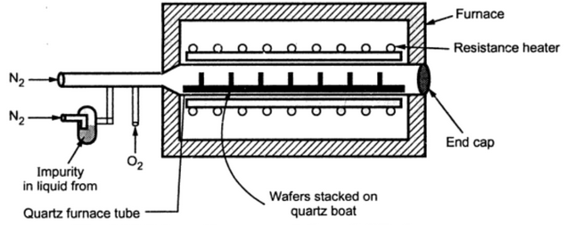

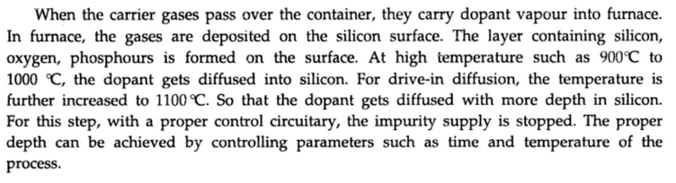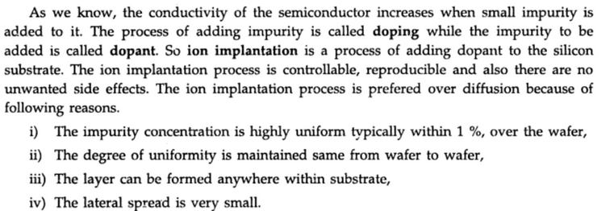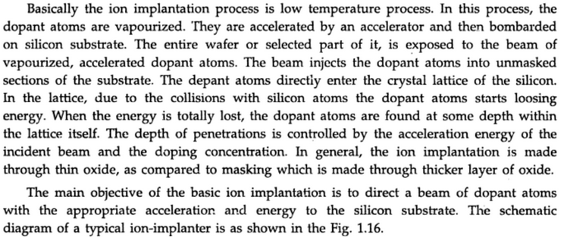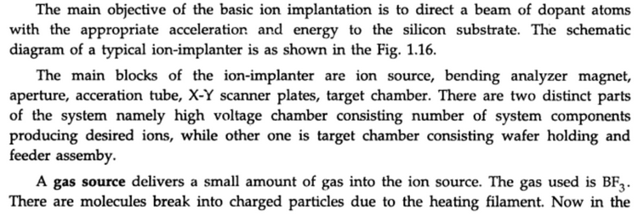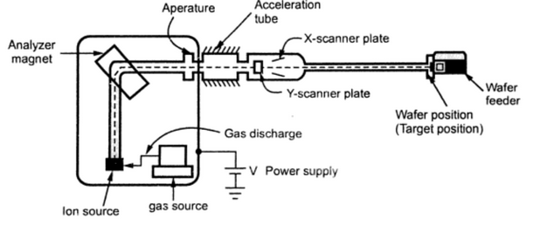

ION Implantor

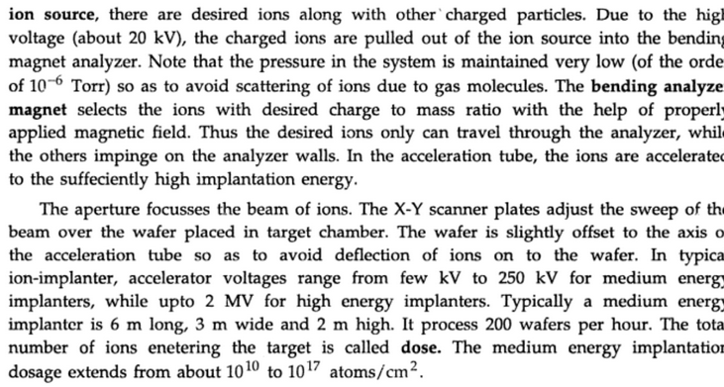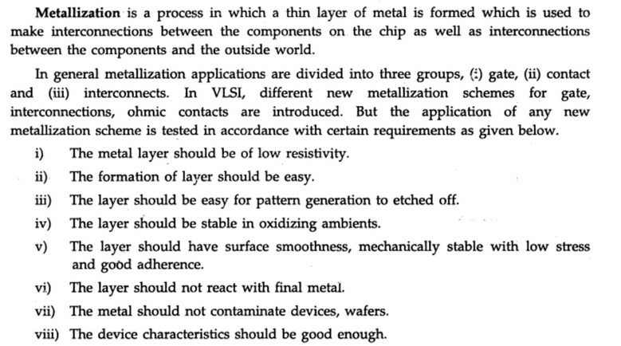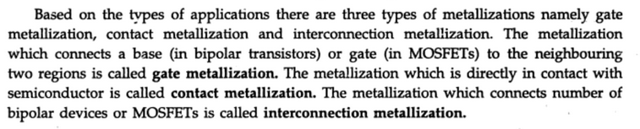

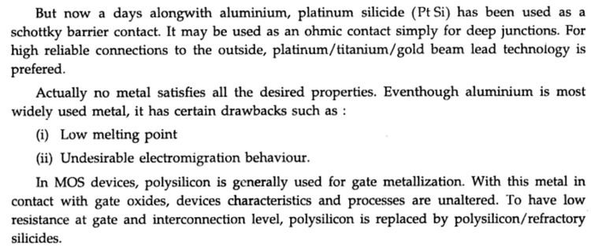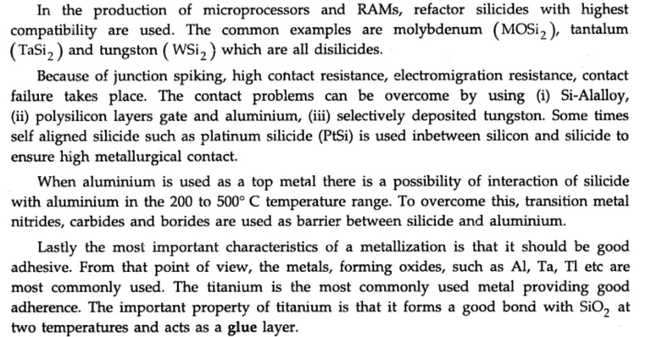

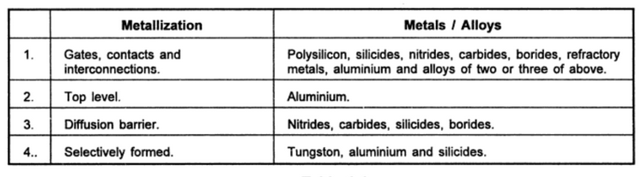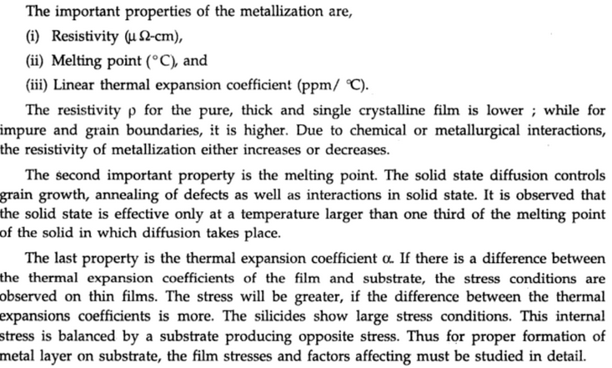

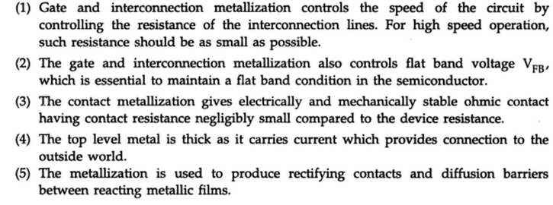

Metalization

Why Al is used for metallization

Aluminium (Al) is the most commonly used material for the metallization of most IC’s, discrete diodes, and transistors. The film thickness is as about 1 micro meters and conductor widths of about 2 to 25 micro meters are commonly used. The use of aluminium offers the following advantages:

* It has as relatively good conductivity.
* It is easy to deposit thin films of Al by vacuum evaporation.
* It has good adherence to the silicon dioxide surface.
* Aluminium forms good mechanical bonds with silicon by sintering at about 500°C or by alloying at the eutectic temperature of 577°C.
* Aluminium forms low-resistance, non-rectifying (that is, ohmic) contacts with p-type silicon and with heavily doped n-type silicon.
* It can be applied and patterned with a single deposition and etching process.

**Metallization Processes**

Metallisation process can be classified info two types:

* CVD and
* Physical Vapour Deposition

CVD offers three important advantages. They are

* Excellent step coverage
* Large throughput
* Low-temperature processing
* The basic physical vapour deposition methods are
* Evaporation
* Sputtering

Both these methods have three identical steps.

* Converting the condensed phase (generally a solid) into a gaseous or vapour phase.
* Transporting the gaseous phase from the source to the substrate, and
* Condensing the gaseous source on the substrate.